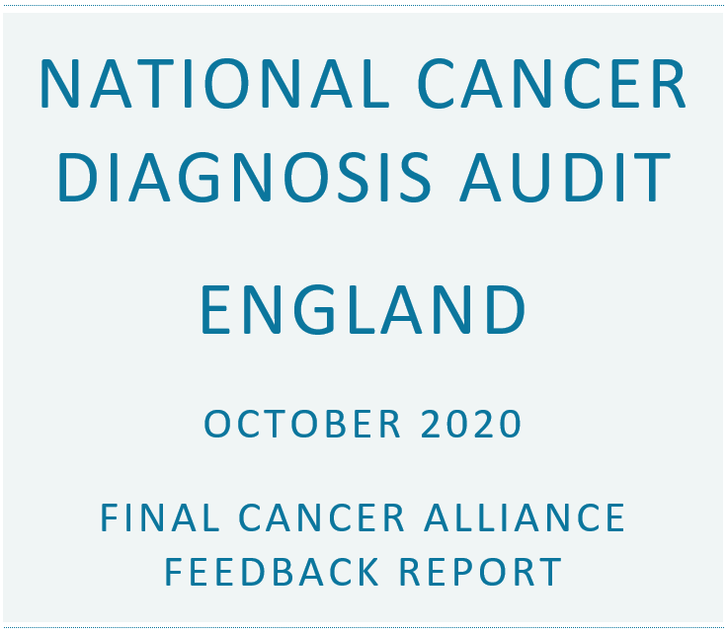

Results for:
- Cancer Alliance: East Midlands
- Number of practices in Cancer Alliance that contributed to NCDA: 62
- Number of cases included in this report: 2464

Introduction

What is included in the report
This report summarises data submitted to the National Cancer Diagnosis Audit (NCDA) on patients diagnosed with cancer in 2018. A comparator to the England national data is included.

How to use the information
These results provide comparative information for benchmarking and reviewing variations. They are intended to help Cancer Alliances think about clinical practice and service delivery in cancer and, in particular, early diagnosis. They are not for the purpose of performance management and there are no 'right or wrong' answers.
At the end of the report the chapter: What to do next describes further recommendations. Please see the glossary for more information on terms used in this report.

Caveats
- Data are only shown for what was entered on the NCDA Portal and may not reflect all patients diagnosed with cancer within this Cancer Alliance in 2018. Although it was not compulsory for practices to submit data on patients who had a screen detected cancer, records that were submitted are included in this report.
- Please note that not all completed data are shown in this report, e.g. symptoms and free text comments, however, they will be used in the national analysis.

Further support
Support from Cancer Research UK's Facilitators/GPs and Macmillan GPs is available. They can discuss your results with you and can provide additional resources you may find helpful. Find out more at www.cruk.org/facilitators and/or email macdocs@macmillan.org.uk.

In Partnership with:

Summary of results
This summary provides an overview of the data from this Cancer Alliance completed for the NCDA up to September 2020. You can use the summary to identify sections in the report you would like to review in detail.
This is the final report for East Midlands Cancer Alliance, based on 2464 completed audit cases for patients diagnosed in 2018. A total of 64600 audits were completed by practices taking part in the NCDA in England.
Please follow the links to the individual results sections, the ‘What to do next’ chapter and glossary for more information on the results for this Cancer Alliance:
Cancer type |  |  | Multiple consultations |  | Primary care interval |  | Demographics
Cancer stage |  |  | Investigations |  | Diagnostic interval |  | What to do next
Place of presentation |  |  | Referrals |  | Safety netting
Consultations |  |  | Emergency referral routes |  | Avoidable delays

Demographics summary
The demographics for the patients (for whom data were completed) from this Cancer Alliance are shown below.
Demographic | This Cancer Alliance | England
Male / female | 52.8% / 47.2% | 51.7% / 48.3%
Median age | 70 years | 70 years
White ethnicity | 92.5% | 86.4%

Cancer type summary
Cancer type | This Cancer Alliance % (n) | England % (n)
Breast | 16.6% (409) | 15.3% (9863)
Colorectal | 10.8% (266) | 10.9% (7056)
Lung | 11.7% (288) | 12.6% (8138)
Prostate | 17.4% (429) | 15.2% (9850)

Place of presentation summary
The most common place where the patient first presented with symptoms, ultimately considered by the GP to be related to the cancer diagnosis was the GP Surgery for 66.0% of patients in the England national data, compared to 69.2% of patients in this Cancer Alliance.
The proportion of patients who first presented at Accident and Emergency with symptoms related to the cancer diagnosis was 7.4% of patients in the national data for England and 5.9% of patients in this Cancer Alliance.

Consultations summary
The proportion of patients who had fewer than 3 consultations before referral was 71.5% of patients in the national data for England and 68.8% in this Cancer Alliance.
The median and interquartile range for the number of consultations, prior to referral by any route, was:
- This Cancer Alliance: 1 consultation (min: 0, interquartile range: 1 - 2)
- England: 1 consultation (min: 0, interquartile range: 1 - 2)
In the England national data, the most common reason for multiple consultations was 'Complexity of presentation' for 53.5% of patients. Compared to 55.1% in this Cancer Alliance.

Investigations summary
The proportion of patients in the national data for England who had at least one primary care led investigation prior to referral was 46.5% and 48.2% of patients in this Cancer Alliance.
Of investigations ordered, the most commonly used investigation in the England national data was a blood test for 59.4%. The same test was ordered for 60.3% of investigations in this Cancer Alliance.

Referrals summary
The most common route of referral for patients in the national data for England was TWW for 54.9% of patients, and 57.5% of patients in this Cancer Alliance. There were 13.4% of patients nationally who had an emergency referral. in this Cancer Alliance, 12.7% of patients were referred as an emergency.

Interval summary
The median primary care interval (time from first presentation of symptoms to referral by any route) was:
- East Midlands Cancer Alliance: 3 days
- England: 2 days
The median diagnostic interval (time from first presentation of symptoms to diagnosis) was:
- East Midlands Cancer Alliance: 32 days
- England: 35 days

Safety netting summary
In the national data for England, the proportion of cases where a safety netting procedure was recorded was 33.9%. In this Cancer Alliance, the proportion was 33.4%.

Avoidable delays summary
In the national data for England, 23.5% of patients were considered by the GP to have had an avoidable delay to their diagnosis. Compared to 24.8% of patients in this Cancer Alliance.

Results Section
The following results section shows more information than given in the above summary on the data submitted to the NCDA for patients diagnosed with cancer in 2018 from the East Midlands Cancer Alliance, and the England national data are provided for benchmarking. Please see the glossary for more information on terms used in this report.

Cancer Type
The figure below shows the proportion of patients by cancer type, as recorded by Public Health England's National Disease Registration. According to the data completed within this Cancer Alliance, prostate cancer was the most common diagnosis (17.4% of diagnoses audited in this Cancer Alliance), compared to 15.2% in the England national data. To compare these data to the cancer incidence figures for England overall and by Cancer Alliance for 2018, please see: www.cancerdata.nhs.uk/incidence/base_numbers
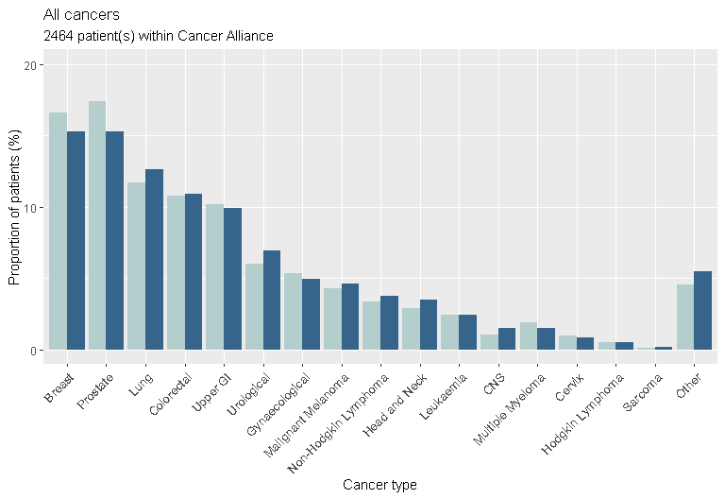
Note
CNS: Central Nervous System (including brain)

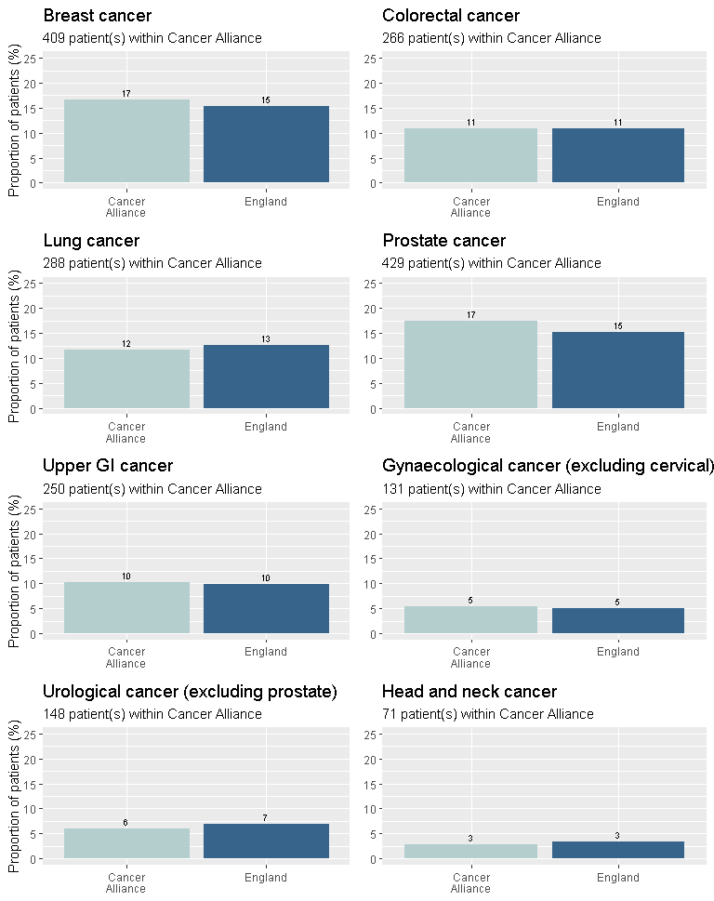

Cancer Stage
The cancer stage at diagnosis, as recorded by Public Health England's National Disease Registration, is shown here. To give more meaningful information due to low numbers, the cancer stages have been combined into 'early' (stages 0/1/2) and 'late' (stage 3/4) (there are a small number of malignant breast cancers that are recorded as stage 0).
In this Cancer Alliance, 43.3% of patients were diagnosed with early stage cancer and 37.9% were diagnosed with late stage cancer. In the England national data, 44.7% of patients were diagnosed with early stage cancer and 37.2% were diagnosed with late stage cancer.

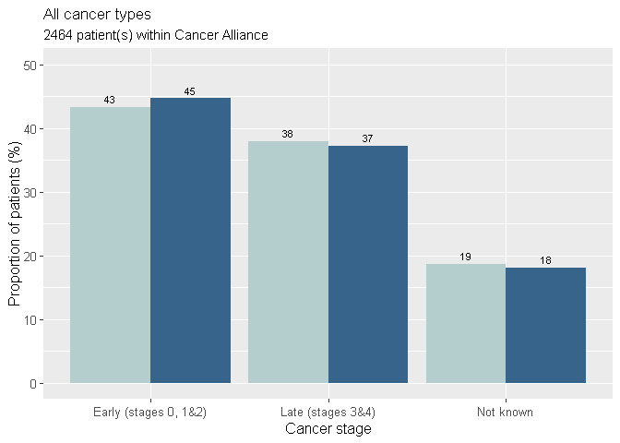
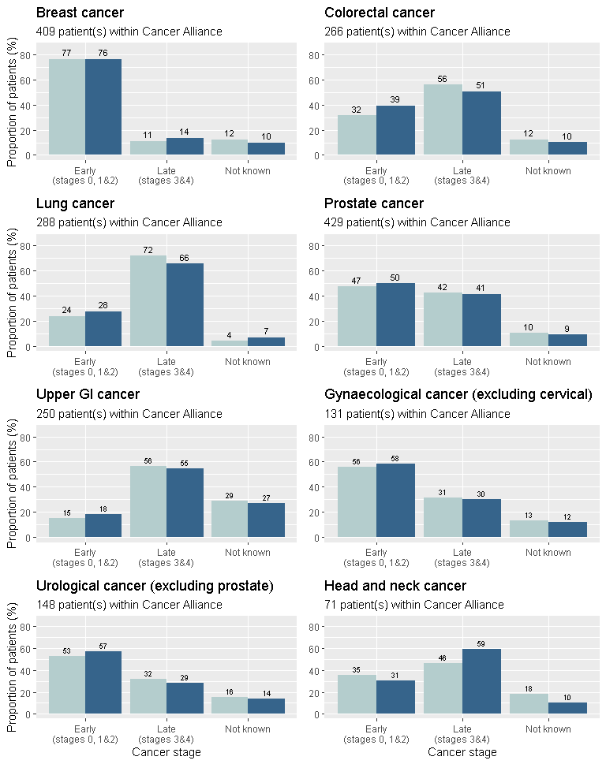

Place of presentation
The following data shows information on the place where the patient first presented with symptoms, ultimately considered by the GP to be related to the cancer diagnosis.
The most common place where the patient first presented was the GP Surgery for 66.0% of patients in the England national data. The proportion of patients who first presented in this way within this Cancer Alliance was 69.2%.
Cases that first presented at A&E have been included as presenting at 'A&E' here. Please note this figure may differ from patients ultimately diagnosed via emergency routes, as patients who first present at A&E are then not necessarily diagnosed via an emergency route, and as patients who first present elsewhere may, ultimately, still get diagnosed through an emergency route.
The following figure shows where patients first presented with symptoms for all cancer types.
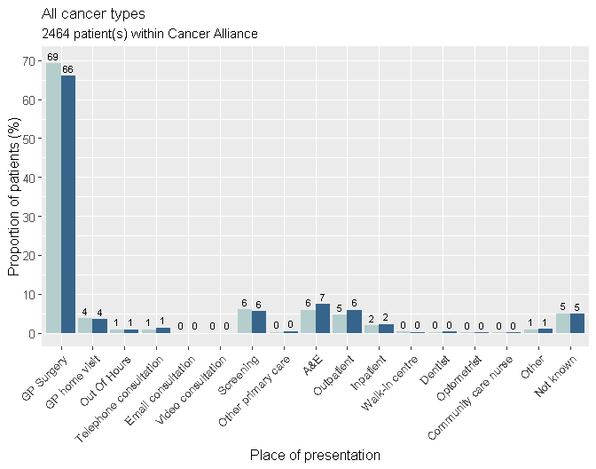

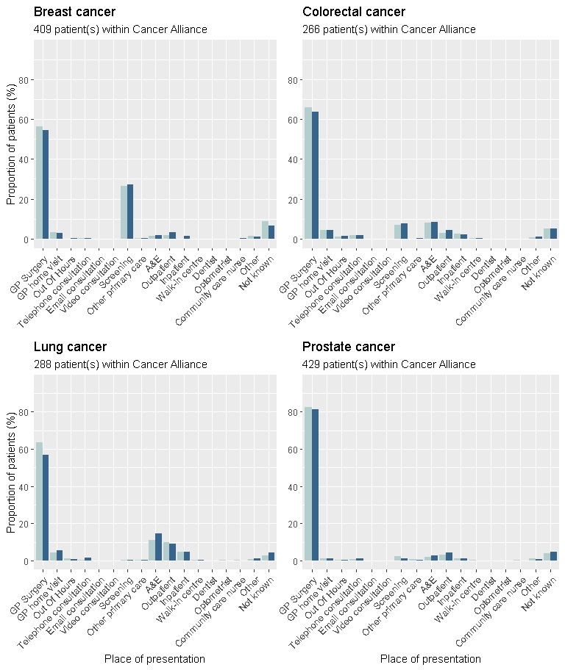

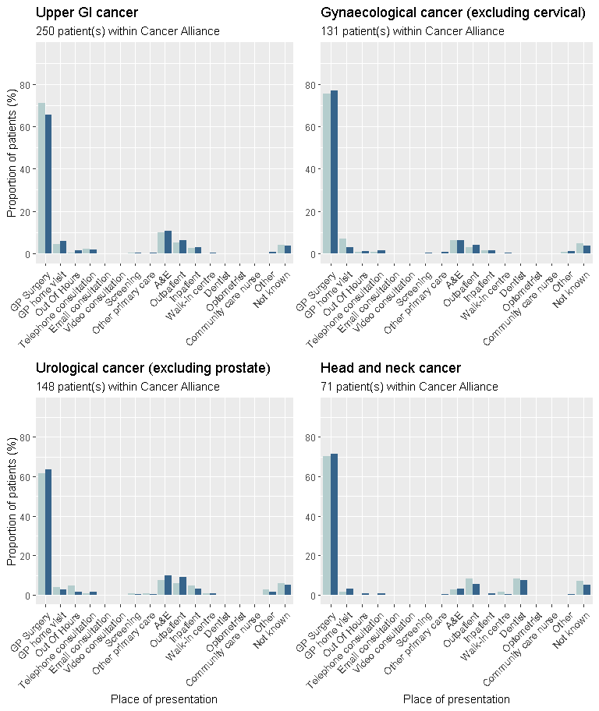

Consultations
The results show the number of consultations for cancer-related symptoms in the year before the referral that led to the cancer diagnosis. This number includes the consultation that led directly to the referral. The definition of a consultation includes email, telephone, nurse practitioner and nurse consultations, in any clinical setting.
The median and interquartile range for the number of consultations, prior to referral by any route, was:
- East Midlands Cancer Alliance:
1 consultation (min: 0, interquartile range: 1 - 2)
- England: 1 consultation (min: 0, interquartile range: 1 - 2)
The proportion of patients who had fewer than 3 consultations prior to referral was:
- East Midlands Cancer Alliance: 68.8%
- England: 71.5%
The consultation numbers have been grouped into 'fewer than 3' and '3 or more consultations'. The graphs below show the proportion of patients in each group.
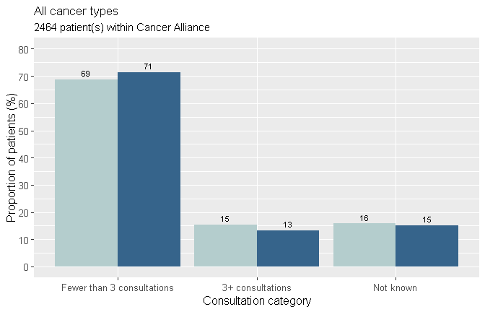
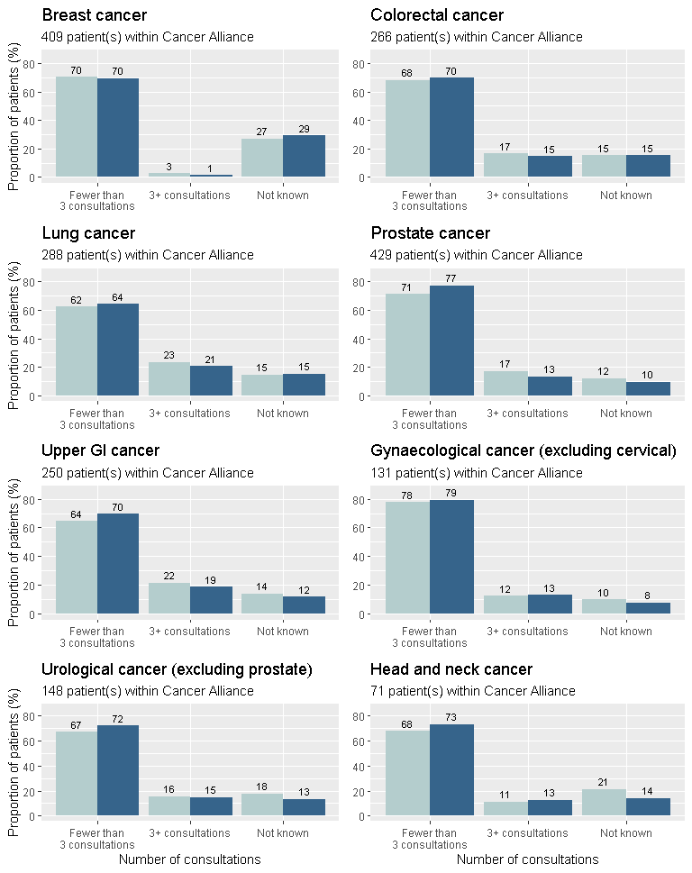

Multiple consultations
The reasons given for why patients had multiple (3 or more) consultations are listed below.
In the England national data, the most common reason for multiple consultations was 'Complexity of presentation' for 53.5% of patients. Compared to 55.1% in this Cancer Alliance for the same reason.
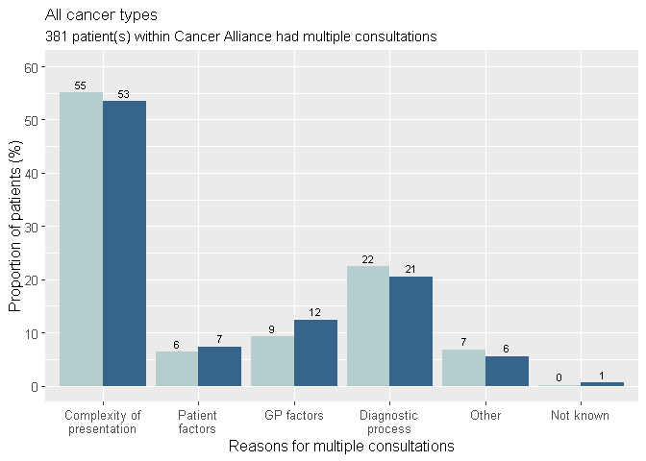
Note
Patients could have had multiple consultations for more than one reason and reasons given have been grouped in the graphs above. Below are examples of reasons included within each group:
- Complexity of Presentation: 'Vague/Non-Specific symptoms', 'Co-morbidity blurring picture', or 'Symptoms suggested different initial diagnosis'
- Patient Factors: 'Patient declined test or referral', or 'Patient did not attend'
- GP Factors: 'Poor communication', 'Inadequate history taken', 'Referred to ‘wrong’ specialty', or 'Seen by multiple health professionals'
- Diagnostic Process: 'Reassurance from negative investigation', or 'Multiple consultations to discuss test results'
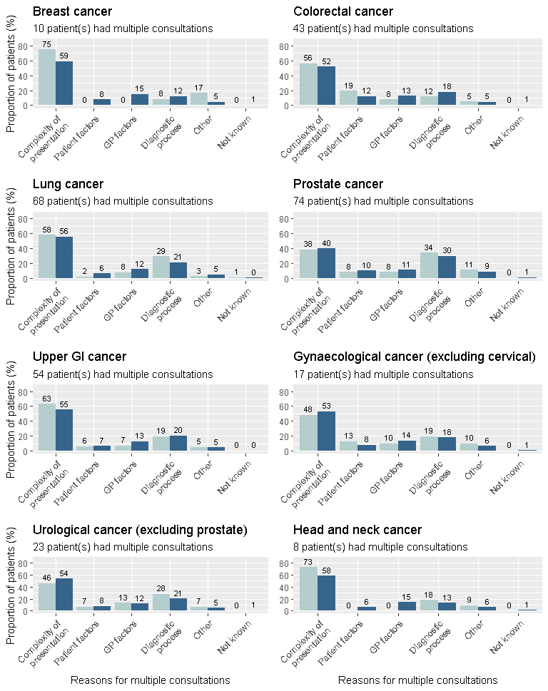

Investigations
The results below show the number of investigations that were ordered in primary care as part of the diagnostic assessment prior to referral and in response to symptoms reported, signs elicited, or abnormal test results. These are investigations where the GP receives the result directly and retains responsibility for acting upon the result.
The proportion of patients who had at least one primary care led investigation prior to referral was 48.2% in this Cancer Alliance and 46.5% of patients in the national data for England. In this Cancer Alliance there were 33.8% of patients who had no investigation, 6.7% not known and 11.3% not applicable. In the national data for England, 37.3% of patients had no investigation prior to referral.
Of primary care led investigations ordered, the most common investigation was a blood test for 59.4% of all investigations nationally. The same test was ordered for 60.3% of all investigations within this Cancer Alliance.
For those patients who had at least one primary care-led investigation, more information on the type of investigations ordered is shown in the graphs below. Only the type of investigation was considered, i.e. the graphs show one blood test per patient even if the patient had more than one blood test.

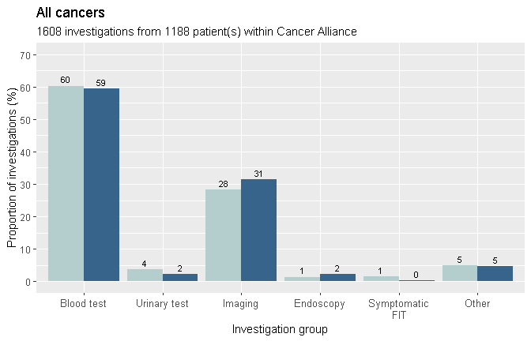

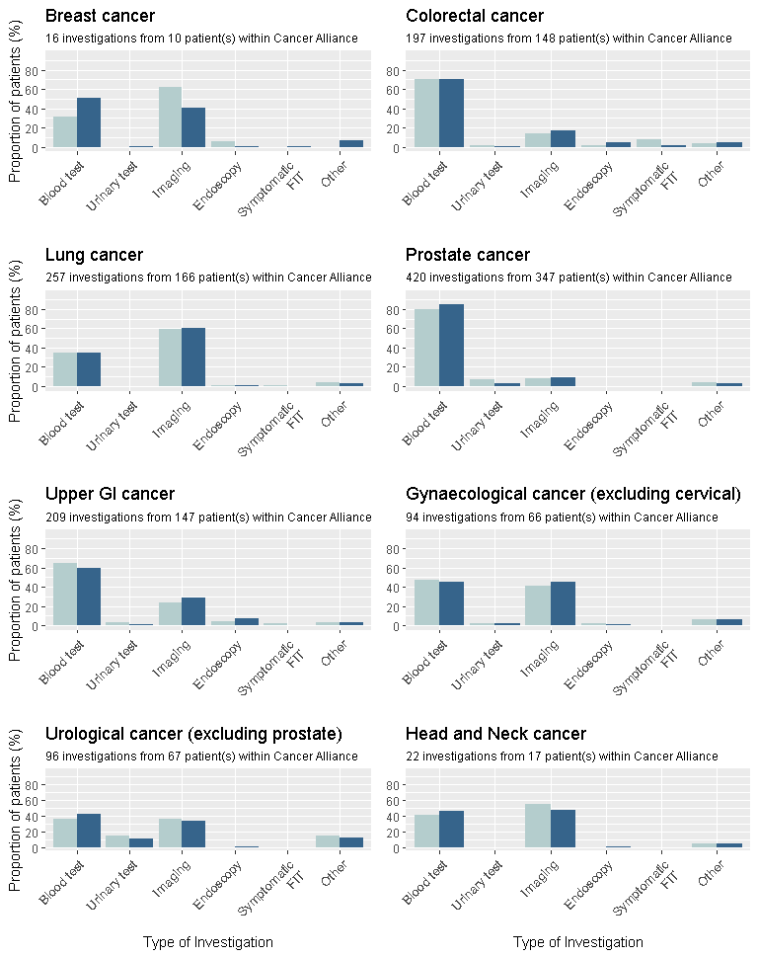

Referrals
This section shows the type of referral that led most directly to a diagnosis of cancer. Where a patient was referred multiple times for reasons attributed to cancer, the closest referral to diagnosis was used.
The proportion of patients referred by Two Week Wait for suspected cancer were:
- East Midlands Cancer Alliance: 57.5%
- England: 54.9%
The graph below shows the proportion of patients who were referred by each route. Further information is shown in the next section of the report for patients who had an emergency referral.
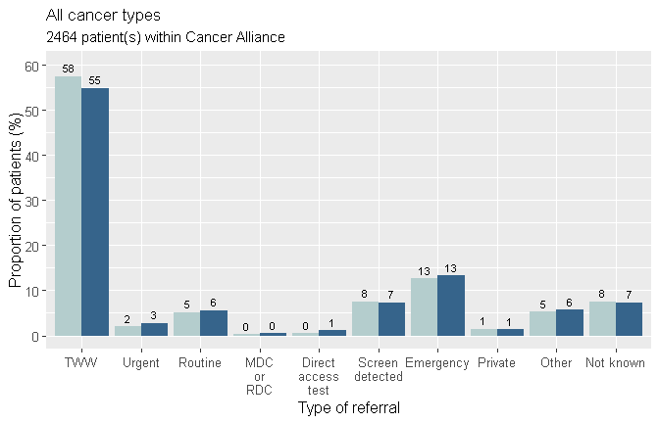
Notes
TWW: Two week wait / urgent referral for suspected cancer
Urgent: Any urgent referral that was not for suspected cancer
MDC or RDC: Multidisciplinary Diagnostic Centre or Rapid Diagnostic Centre - referral pathway for patients with non-specific but concerning symptoms that could indicate cancer
Emergency: All emergency referrals, including patient self referral

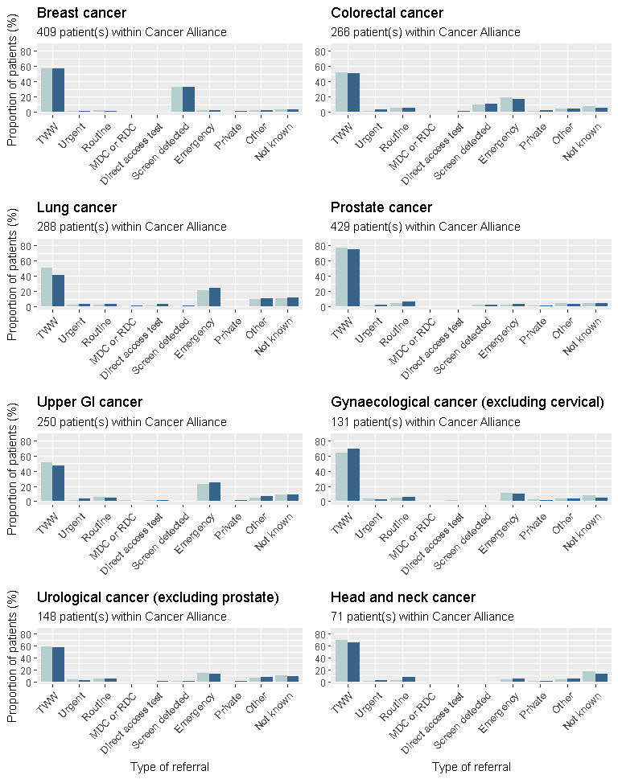

Emergency referral routes
This section provides details on emergency referrals, specifically whether or not a patient had contact with the GP before their emergency referral, and whether the GP had already initiated tests or made a referral. Note: this is not the same as the A&E group in the ‘Place of First Presentation’ section above, which provides details on where patients first presented and not on their referral.
Of patients referred by any emergency route nationally (13.4%), the most common route of referral was 'Patient self-referred to A&E / hospital, without any prior relevant GP consultations' for 29.2% of emergency referred patients. 12.7% of patients in this Cancer Alliance were referred by an emergency route, and 25.6% of these were diagnosed through the most common national route (self-referral without any prior consultation).
The following graphs show the proportion of patients who were referred by the different emergency routes. Note: Only patients who had an emergency referral are shown in the graph below.
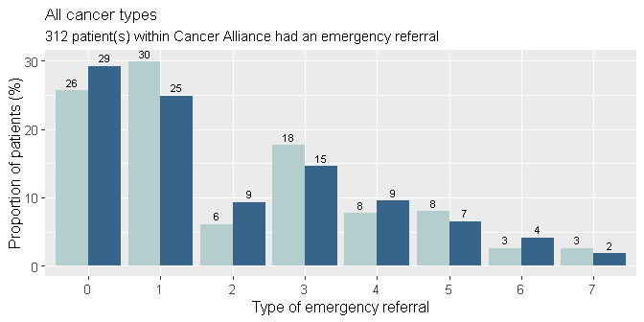

Key of emergency referrals:

0. Patient self-referred to A&E / hospital, without any prior relevant GP consultations

1. Patient was referred to A&E / hospital as an emergency by the GP or OOH service (e.g. emergency A&E or emergency admission to surgical or medical ward) – patient had no prior relevant GP consultations

2. Patient self-referred to A&E / hospital having previously consulted the GP during the same episode of illness but not awaiting a previously arranged test or referral

3. Patient was referred to A&E / hospital as an emergency by the GP or OOH service having previously consulted the GP during the same episode of illness but not awaiting a previously arranged test or referral

4. Patient self-referred to A&E / hospital while waiting for referral / investigation arranged by GP previously (e.g. sudden deterioration of patients’ symptoms while waiting to be assessed in hospital electively)

5. Patient was referred to A&E / hospital as an emergency by the GP or OOH service (e.g. emergency A&E or emergency admission to surgical or medical ward) – patient was awaiting to be assessed in hospital following prior referral

6. Other

7. Not known / circumstances leading to emergency presentation cannot be verified
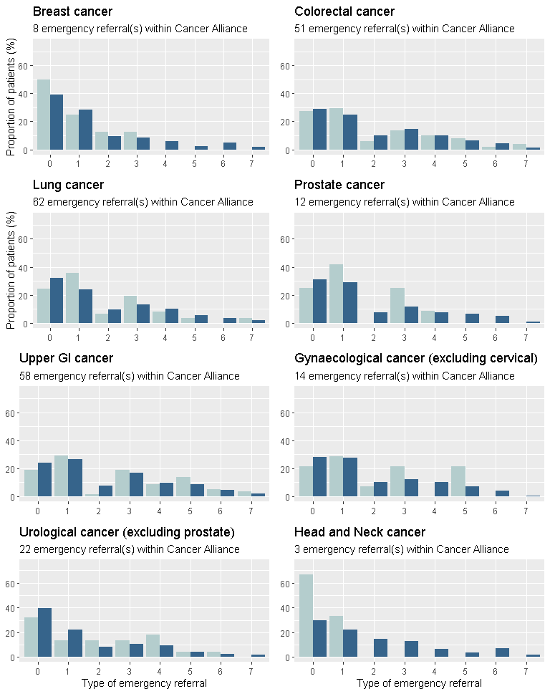

Primary Care Interval
This section shows the number of days from when the patient first presented with symptoms, ultimately considered by the GP to be related to the cancer diagnosis, to the date of first referral from primary care.
The median time from first presentation to referral was:
- East Midlands Cancer Alliance: 3 days
- England: 2 days

The dot in each of the plots below represents one patient and the time (in days) from first presentation of symptoms to referral (x-axis), the further to the right a dot is on the graphs, the longer it took for that patient to be referred. Data are only shown where there was a date for presentation and referral - therefore patients who had no referral recorded are not included in these results.

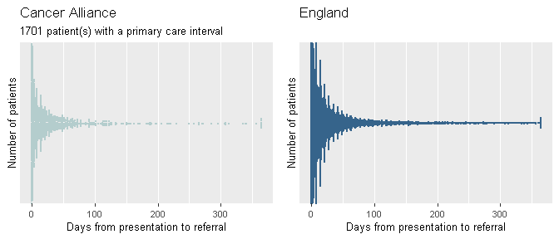

Diagnostic Interval
This section shows the number of days from when the patient first presented with symptoms ultimately considered by the GP to be related to the cancer diagnosis, to the date of cancer diagnosis (as recorded by Public Health England's National Disease Registration).
The median time from first presentation of symptoms to diagnosis was:
- East Midlands Cancer Alliance: 32 days
- England: 35 days

The dot in each of the plots below represents one patient and the time (in days) from first presentation of symptoms to diagnosis (x-axis), the further to the right a dot is on the graphs, the longer it took that patient to be diagnosed. Data are only shown where there was a date for presentation and a date of diagnosis recorded.

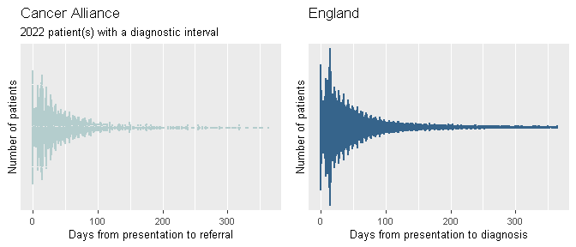

Safety Netting
Information was collected on whether there was evidence in the clinical record that safety netting was used and recorded at any stage of the patient's diagnostic process and the type of safety netting used. The 'not applicable' option was selected if safety netting was not relevant, e.g. the patient self-presented to A&E without having had any prior relevant GP consultations. Screen-detected cases, where data were not entered, are included in the 'not applicable' category.
The proportion of cases where a safety netting procedure was recorded was 33.4% within this Cancer Alliance and 33.9% in the England national data.

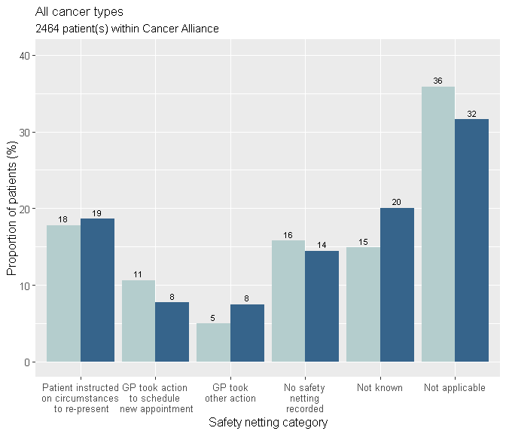
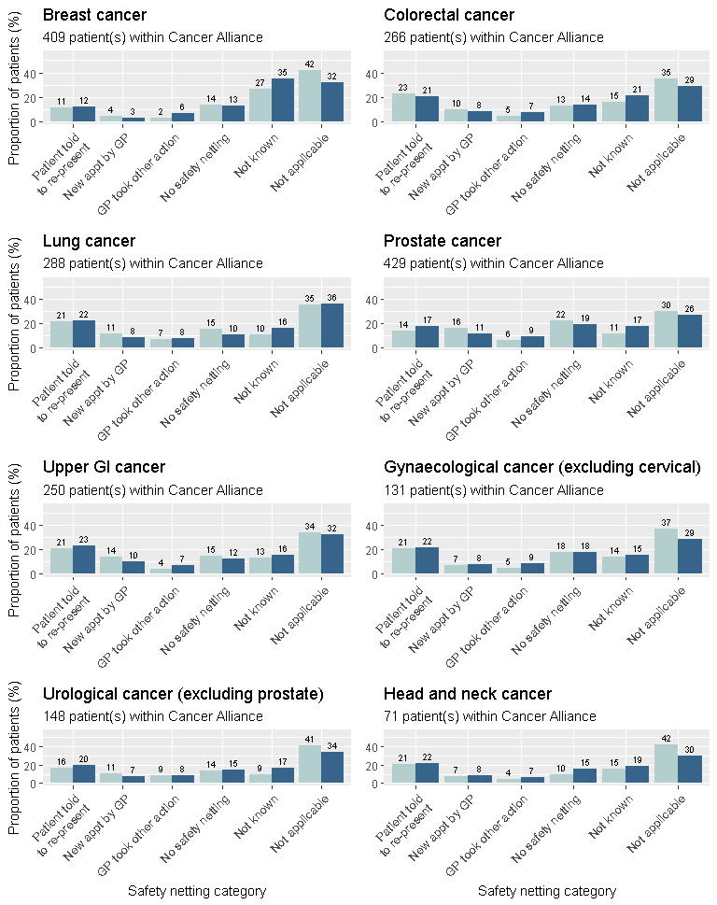

For patients for whom the GP reported that safety netting had been used, the graphs below show whether the GP felt that safety netting had made a positive contribution to the diagnosis, had not made a positive contribution, or where the impact of safety netting was unknown or not applicable.

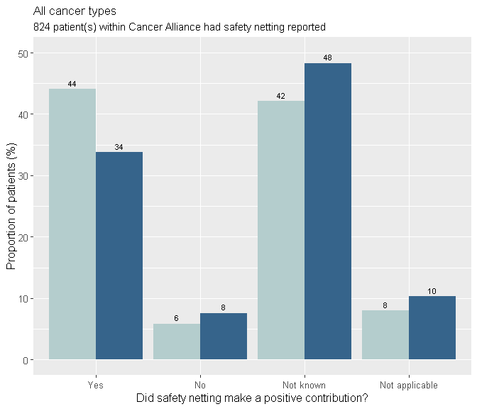
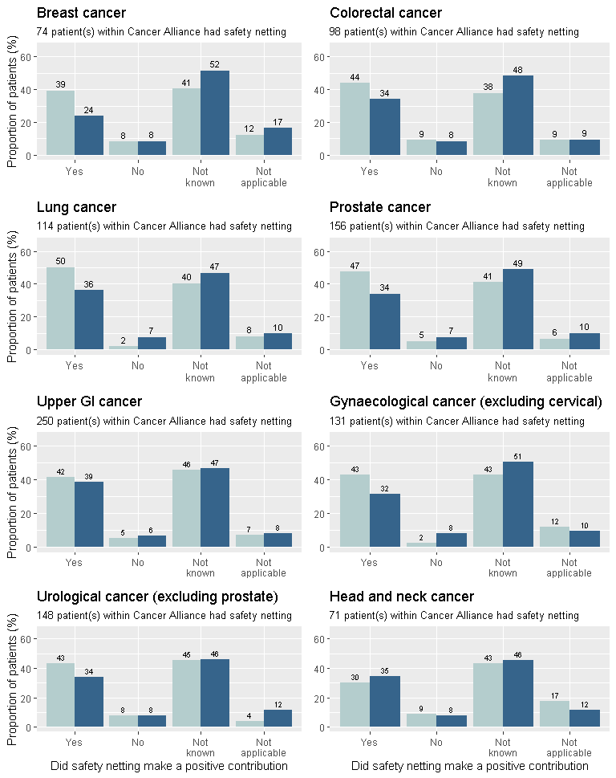

Avoidable delays
This section shows information about cases in which, with hindsight, the GP believed there to have been an avoidable delay in the patient receiving their diagnosis. Overall, the proportion of patients with a GP-assessed avoidable delay was 24.8% within this Cancer Alliance and 23.5% in the England national data.
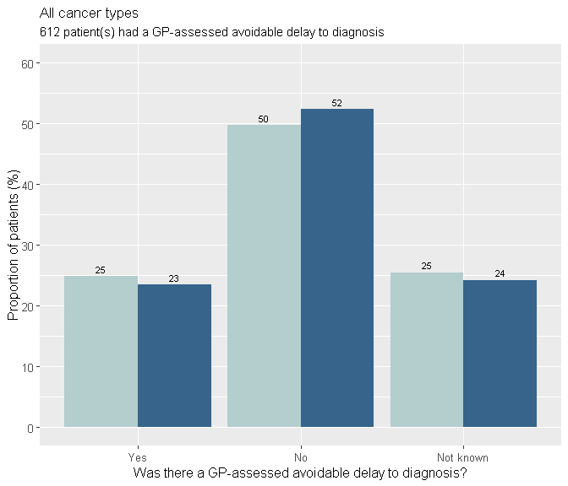

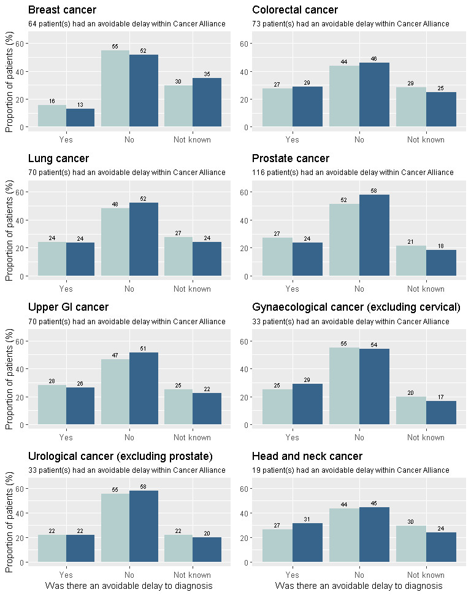

When did avoidable delay occur?
An avoidable delay could have occurred before presentation of symptoms, between presentation and referral, and/or after referral. For patients who were judged by the GP to have experienced an avoidable delay, the table below shows the proportion that experienced an avoidable delay at different stages in the pathway.
Note: each patient who experienced avoidable delay may have experienced this at one or more stage(s) in the pathway and may therefore be included in more than one column. Proportions do not include patients who had a screen-detected cancer.
For patients who experienced an avoidable delay (n=612 / 24.8% of patients audited in this Cancer Alliance):
Region: | Avoidable delay  before presentation | Avoidable delay between  presentation and referral | Avoidable delay  after referral
Cancer Alliance | 45.6% | 46.1% | 33.5%
England | 43.7% | 43.9% | 39.3%

Demographics
This section provides a summary of the patient demographics for the NCDA data completed within this Cancer Alliance on patients diagnosed with a new primary cancer in 2018. Note: these are the demographics for cancer patients for whom practices in the Cancer Alliance completed this audit and these may not reflect the Cancer Alliance population overall.

Sex
The patients diagnosed with cancer in this Cancer Alliance were mostly male (52.8%), as recorded by Public Health England's National Disease Registration. The patients diagnosed with cancer in England were mostly male (51.7%). The figures below show the proportion of patients by sex.
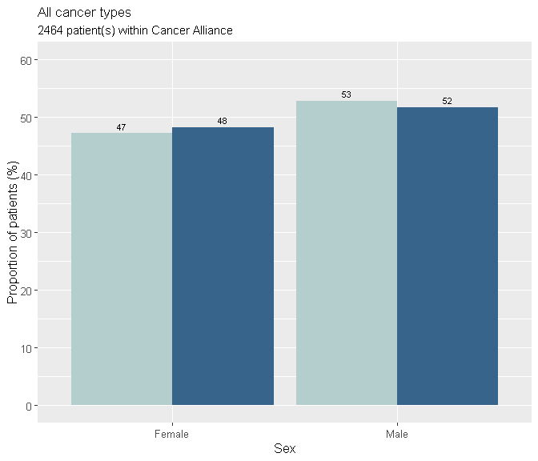
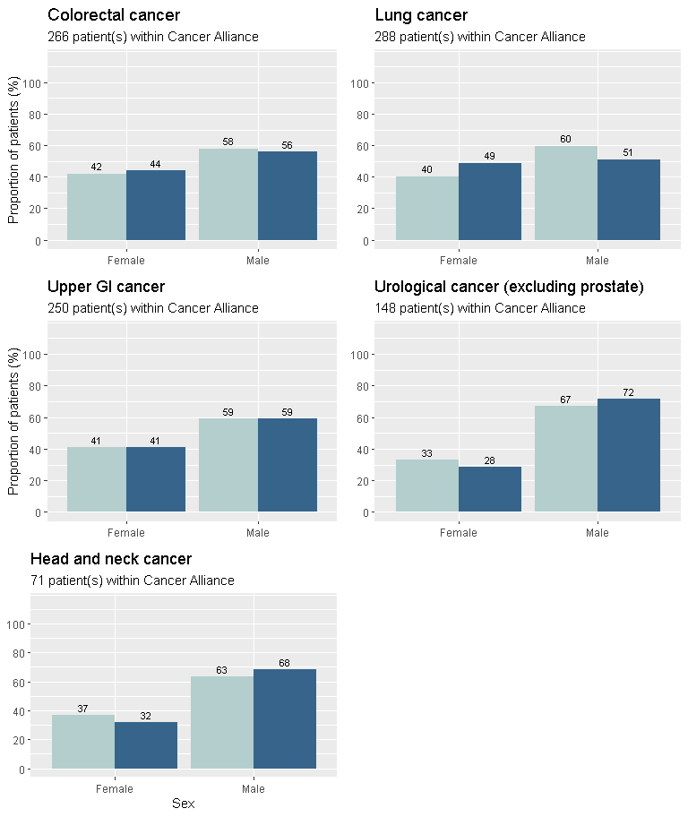
Note: breakdown by sex has not been included for cancers that primarily/only affect one gender, e.g. breast, prostate and gynecological cancers

Age
The age group of most patients with cancer in this Cancer Alliance was 65-74 years (32.3%), as recorded by Public Health England's National Disease Registration. The largest proportion of patients diagnosed with cancer in the England national data were in the age group 65-74 (29.7%). The figures below show the proportion of patients by age group.
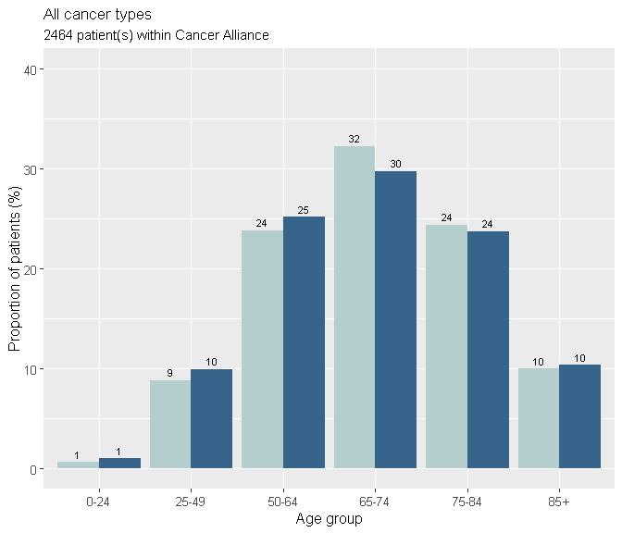
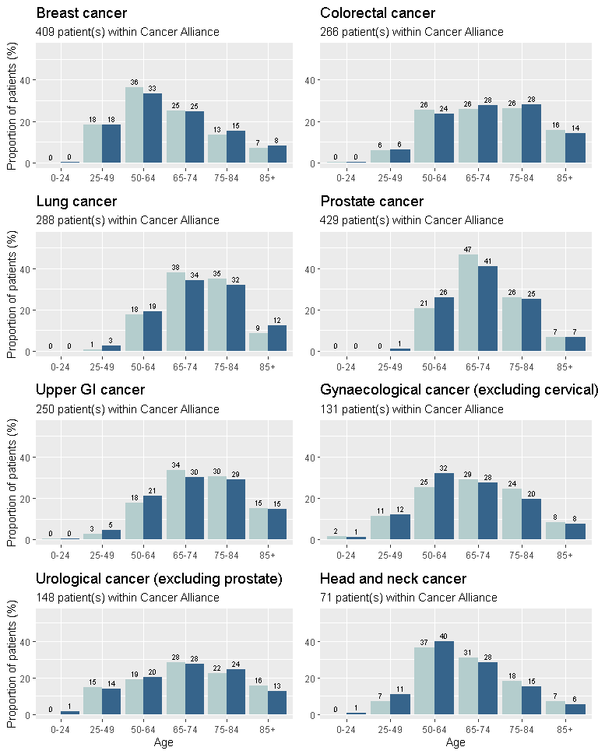

Ethnicity
The patients with cancer in this Cancer Alliance were mostly white ethnicity (92.5%). In the England data the patients were mostly white (86.4%), as recorded in the cancer registry. The figures below show the proportion of patients by ethnicity.
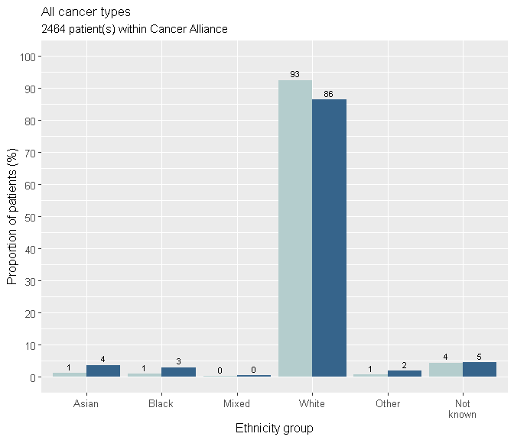
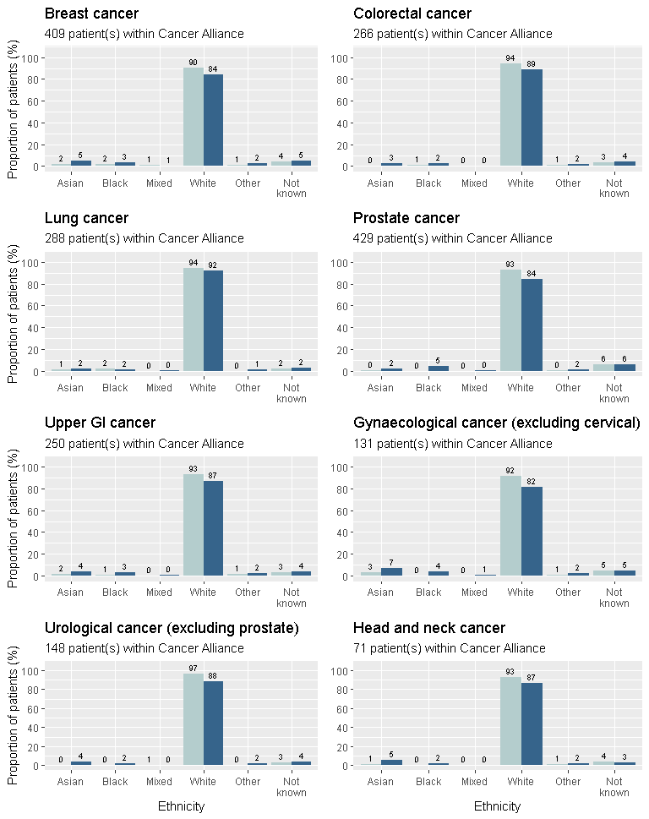

Co-morbidities
The proportion of patients who had at least one co-morbidity present prior to cancer diagnosis was 71.8% in this Cancer Alliance and 71.2% of patients in the national data for England. In this Cancer Alliance, 23.1% of patients had no co-morbidities recorded and 5.1% not known. In the national data for England, 21.8% of patients had no co-morbidities prior to cancer diagnosis.
Co-morbidities present prior to cancer diagnosis were documented and multiple selections could be made. If a patient had more than one co-morbidity reported, they will be counted in multiple groups in the graph below.
The most common co-morbidity reported for patients with cancer in the England national data was hypertension (24.8% of all co-morbidities, compared to 24.8% in this Cancer Alliance).
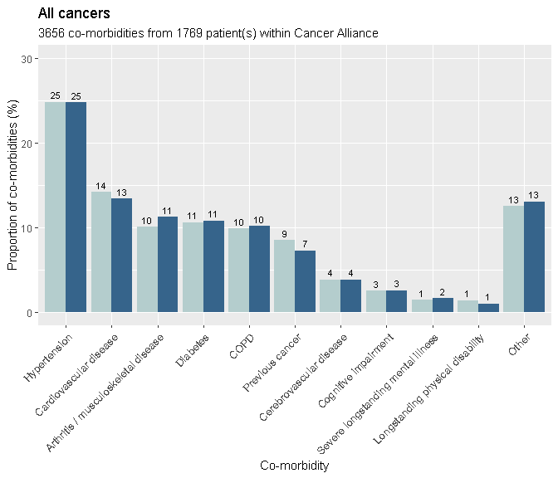
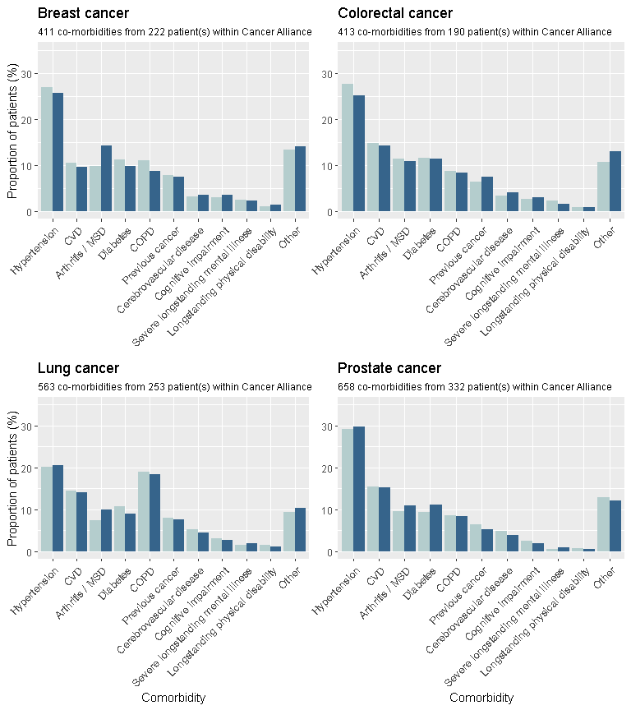

CVD: Cardiovascular disease
MSD: Musculoskeletal disease
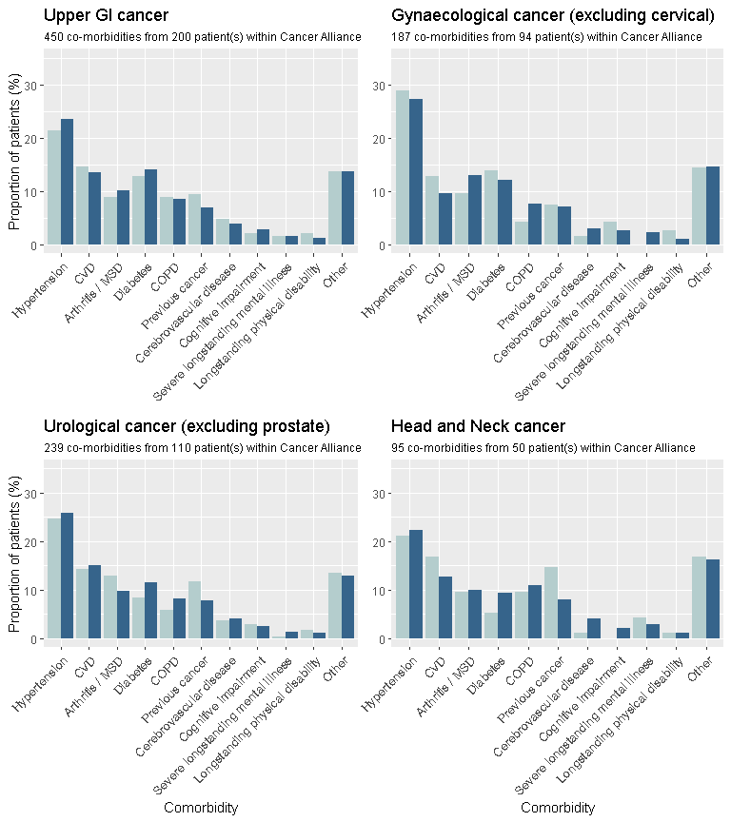

CVD: Cardiovascular disease
MSD: Musculoskeletal disease

What to do next
Support from Cancer Research UK’s Facilitators and GPs, as well as Macmillan GPs is available. They can discuss the Cancer Alliance results with you and can provide additional resources you may find helpful. Find out more at www.cruk.org/facilitators or email NCDA@cancer.org.uk. Find your Macmillan GP by emailing macdocs@macmillan.org.uk (please note that not all areas in England will have a Facilitator or Macmillan GP).

Recommended next steps

Share and discuss your results
GP practices, CCGs, NHS Trusts, local Healthwatches and others in the area may be interested in these results and what they mean for cancer care regionally. You could share the key findings from your report in a local newsletter or bulletin, and you could also consider sharing insights at PLT events or other meetings attended by relevant stakeholders. We recommend that you use such opportunities to highlight good practice identified in the report, identify areas for improvement and consider actions to take forward regionally.
Cancer Research UK Facilitator or GP may be able to help present the findings and can share case studies and learnings from other areas and from the national data. They can also provide certificates for activities relating to the NCDA that they undertake with GPs, which can count towards CPD.
Resources that could be helpful: You can request a PowerPoint template to support presentation of Alliance level findings by emailing NCDA@cancer.org.uk.
You may also consider sharing your key insights and learning beyond your immediate area, for example with other Cancer Alliances and/or NHS England's Cancer Programme, or at conferences and events when the opportunity presents itself.

Agree Actions
Depending on the results, there may be some actions you decide to take forward within your area. These could include changes to systems and processes, such as referral forms or safety netting advice, hosting of events to allow sharing of best practice and/or to provide training for primary care staff, public education campaigns to encourage help seeking, and/or other quality and service improvement activities.
Cancer Research UK Facilitators, CRUK GP or Macmillan GP can offer advice and support for any actions you decide to take. It’s important to think about how you will monitor the implementation and impact of any activities undertaken regionally.
The NCDA findings can also help monitor implementation of NG12 referral guidelines, and as a baseline to better understand the impact of the coronavirus pandemic on cancer pathways and services going forward.
Resources that could be helpful: The Quality Improvement Toolkit for the Early Diagnosis of Cancer: www.rcgp.org.uk/-/media/Files/CIRC/Toolkits-2017/Cancer/NCDA-toolkit-110917b.ashx?la=en

Other useful Resources
Depending on your reflections, you may also wish to:
Review area-level data at PHE Fingertips - Cancer Services. To view data on cancer screening, Two Week Wait referrals, diagnostic services, emergency presentations and admission at NHS region and for England: fingertips.phe.org.uk/profile/cancerservices
Visit the Cancer Research UK GP Contract Hub for information and resources around cancer-related requirements in the GP contract and PCN DES: www.cruk.org/GPcontract
Review the "NG12 Suspected cancer: recognition and referral guidelines": www.nice.org.uk/guidance/ng12
Share different types of summaries of the "NG12 Suspected cancer: recognition and referral guidelines":
- www.macmillan.org.uk/documents/aboutus/health_professionals/pccl/rapidreferralguidelines.pdf
- www.cancerresearchuk.org/health-professional/learning-and-development-tools/nice-cancer-referral-guidelines
- www.gatewayc.org.uk/gwc-cancer-map/
Find more information and e-learning about cancer: www.cruk.org/hponlinelearning

You may also wish to signpost to quality improvement resources for primary care:
Refer to The Quality Improvement Toolkit for the Early Diagnosis of Cancer: www.rcgp.org.uk/-/media/Files/CIRC/Toolkits-2017/Cancer/NCDA-toolkit-110917b.ashx?la=en
Refer to the RCGP Handbook "Quality improvement for General Practice: A guide for GPs and the whole practice team": www.rcgp.org.uk/clinical-and-research/our-programmes/-/media/E96023402AFE4CF98C8634A7A1C63196.ashx
Review the RCGP Quality Improvement web pages: www.rcgp.org.uk/clinical-and-research/our-programmes/quality-improvement.aspx
Find links to further e-learning, resources, toolkits, infographics and more at www.cruk.org/ncdaresults

Glossary
- Avoidable delay: Instances where the GP considered there to be an avoidable delay in the patient receiving their diagnosis. The location where the delay was deemed to have occurred could be pre-consultation, primary care, secondary / tertiary care or not known.
- Consultations: The number of consultations for cancer-related symptoms up to one year before the referral that led to the cancer diagnosis, including the consultation that led directly to the referral. This includes email, telephone, nurse practitioner and nurse consultations, in any clinical setting.
- Ethnicity: Patient ethnicity as recorded in the cancer registry at Public Health England's National Disease Registration.
- Interquartile range: When all values are ranked low to high, this is the range of values from the first quartile (25%) to the third quartile (75%), giving the range of values in the middle 50% of data.
- Investigations: The primary care led (ordered) investigations that were ordered as part of the diagnostic assessment decided by the GP and in response to symptoms reported, signs elicited, or abnormal test results. These are investigations that are carried out prior to referral where the GP receives the results directly and retains responsibility for acting upon them. The number of investigation type was counted e.g. the graphs show one blood test per patient even if the patient had more than one blood test.
- MDC: Multidisciplinary Diagnostic Centre - referral pathway for patients with non-specific but concerning symptoms that could indicate cancer
- Median: When all values are ranked low to high, this is the middle value. The median is displayed because the data are skewed and providing the mean average could be misleading.
- Multiple referrals: Number of specialty referrals made by the GP surgery (including referrals to different specialties, or multiple referrals to the same specialty).
- Place of presentation: The place at which the patient first presented with symptoms, which the GP considered to be related to the diagnosis of cancer.
- RDC: Rapid Diagnostic Centre - referral pathway for patients with non-specific but concerning symptoms that could indicate cancer
- Referral: The type of referral that led most directly to a diagnosis of cancer. Where a patient was referred multiple times for reasons attributed to cancer, the closest referral to diagnosis was used. The same applied for emergency referrals.
- Safety netting: Safety netting is a 'diagnostic strategy' or 'consultation technique' to ensure timely re-appraisal of a patient's condition.
- TWW: Two Week Wait, urgent referral by GP for suspected cancer.

Links back to main sections:
- Introduction
- Summary of results

- Results Section
- Cancer type
- Place of presentation
- Consultations
- Multiple consultations
- Investigations
- Referrals
- Primary care interval
- Diagnostic interval
- Safety netting
- Avoidable delays
- Demographics

- What to do next
- Glossary

